
Version 8.0
Updates history

Version 8.04
Compatibility 7.2 | No

Version 8.04.043 | 27/06/2010

Problem fixed concerning EDI protocol for Glassver: WinPro now deletes the EDI file generated when printing a glass order form, when this file is empty and does not contain any glass unit.

WinPro/D and multi-sashes fitting frames: When importing the technical database into WinPro/D, if the program detects the key « Qinc Multi Ouvrant = 0 » (multi sashes for fittings feature, refer to release note 8.03), and if table CorCmp contains multiple records of sashes for a single fitting frame, WinPro/D will automatically assign 1 to the key.
This test is done when data.pak file is imported as well as at the program startup.

Version 8.04.041 | 26/08/2010
Modified tables | Created tables
None | None

Data import for WinPro/D using command line: It is now possible to import fabricator data for WinPro/D (data.pak file) silently and automatically, using a command line.

Examples :

WinProD.exe /import path_to_file_without_filename
or
D:\Program Files\WinproD\winprod.exe /import .\

Attention !
The path to the file should not contain any space character, and the filename should not be written into the instruction !

Version 8.04.039 | 27/06/2010

Default texts for customer documents: It is now possible to assign default start and end texts for customer documents for each customer record.
Create the text itself first using menu Tools | Preferences, Texts tab, and set the corresponding number into the Customer file, section “ Predefined texts “ of the Relations tab.
Those texts are loaded when selecting a customer code, and may still be modified through the Texts tab of the order or quote.

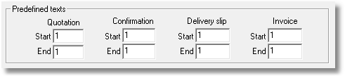

Version 8.04.037 | 26/08/2010
Modified tables | Created tables
None | None

Window encoding in case of sill: When a first window is encoded including a door or window sill, the next windows encoded will automatically retrieve this sill by default. This may now be adapted, through a new key into settings table.

[System]
Copie Seuil = When set to 0, WinPro does not copy the door or window sill from the first design to others.
When set to 1, WinPro will copy the sill from the first encoded design to others.

Version 8.04.036 | 27/06/2010

WithoutGlazing variable within ventilators set up: This variable for ventilators (release note 1.3.16) determines when a ventilator is used along with a glass unit (0), or without when the ventilator is located near enough from a transom to need a glass element (1).
An error message assists you for encoding the ventilator, and the variable behaviour has been fixed.
We consider here GH the remaining glazing height between a transom and a ventilator.
- if 50mm > GH >= 1, WithoutGlazing = 0, an error message suggests to close the transom up to the ventilator.
- if GH < 1, WithoutGlazing = 1, no glass unit computed here.
- if GH <= -1, WithoutGlazing = 1, an error message suggests to move the transom away from the ventilator.

Input message for glazing bars drawn by formula: A message is now displayed when setting a glazing bar frame into a design. This message requets to set a number of cells greater or equal to 2 in case of a glazing bar frame drawn by formula.

Enhancement for creation of the technical database for WinPro/D: The WinPro/D database remains now not generated, and a message is displayed, when the following cases occur :

- When an exported sash frame is not linked to any fitting frame, or when all fitting frames linked to the sash frame are checked as “Exclude from WinPro/D”.
- When an exported system does not contain any outer frame, or when all the outer frames from a system are checked for box “Exclude from WinPro/D”.
- When an exported system does not contain any sash frame, or when all sash frames from a system are checks “Exclude from WinPro/D”.
- When an exported system does not contain any bead frame, or when all bead frames from a system are checked as “Excluded from WinPro/D”.

This check is done only for system with box “Invisible” is left unchecked.

Version 8.04.027 | 27/06/2010

Enhancement for articles import feature: When an articles is imported into the database from a WPX file, WinPro imports now information related to table JnlStock. Stock movements history is now kept for articles when the are exported/imported.

Version 8.04.024 | 27/06/2010

New WPREPORT function: The following functions are used into WPR documents used for module Soprofen Export.
The ExportCaisson (Filename: string ; Code : string) function allows to generate a WPX export file from a roller shutter box;
- Filename set here the complete name and path of the export file to be generated for the roller box.
- Code corresponds to the code of a roller box of the database to export into a WPX file.

The ExportTablier (Filename: string ; Code : string) function allows to generate a WPX export file from a roller shutter curtain;
- Filename set here the complete name and path of the export file to be generated for the roller curtain.
- Code corresponds to the code of a roller curtain of the database to export into a WPX file.

The ExportCoulisse (Filename: string ; Code : string) function allows to generate a WPX export file from a roller shutter guide;
- Filename set here the complete name and path of the export file to be generated for the roller guide.
- Code corresponds to the code of a roller guide of the database to export into a WPX file.

The ImportWPX (Filename: chaine) function allows to import a WPX file into the database;
- Filename set the complete name and path of the WPX file to be imported into the database.

New module import/export for SOPROFEN: This new module, based onto WPR reports, allows to export or import a data set related to roller shutters, in particular roller Box, Curtain and Guide.
This module is available through menu Data | Soprofen | Importation/Exportation.

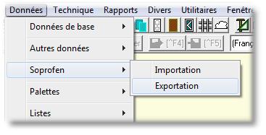
Enable feature:

To enable the module, you need a suitable licence file, as well as the fiollowing elements:
- The Articles codes to be exported should belong to one of the supplier codes defined into WinPro.ini file. See below.
- Codes for roller Boxes, Curtains and Guides should start with a prefix “SO-“ in order to be displayed into the list of elements to export, or to be imported.
- A [Soprofen] section should be added into WinPro.ini file, with the following keys:

[Soprofen]
chemin = Directory where exported records will be stored, and where WinPro will retrieve elements to import. Default value « .\Export_Soprofen\ ».
Count = n The ‘n’ value corresponds to the number of supplier to explore for articles export. Attention, WinPro will create by default 2 values (Count>= 2, default value). See following keys.
n = As many lines as defined by the Count key, corresponding to supplier codes of articles that will be exported. WinPro will defaultly create keys « 1=SOPROFEN » and « 2=SOPROF€N », but it is possible to add custom lines with your own supplier codes to be exported. Both lines created by WinPro should be left as is, for the program to work correctly.

Attention !
Those keys must be created into WinPro.ini file and not into Settings table.

Sample [Soprofen] section:

[Soprofen]
chemin=.\ExpSoprof\
count=3
1=SOPROFEN
2=SOPROF€N
3=QUADRA

This sample sets that files are exported into (or imported from) directory “ExpSoprof” located into the program base directory (it will be created if not existing).
3 suppliers codes will be considered, articles from suppliers “SOPROFEN”, “SOPROF€N” and “QUADRA” will be imported/exported.

Usage:

- Export (menu Données | Soprofen | Export) stage will generate a list of files with WPX format into a subdirectory (“chemin” key).

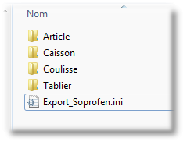

Export movements are traced into a history file “Export_Soprofen.ini” of this subdirectory. This file is overwritten in case of successive exports. It will trace date and time of the last export, as well as the numbers and names of the exported codes.

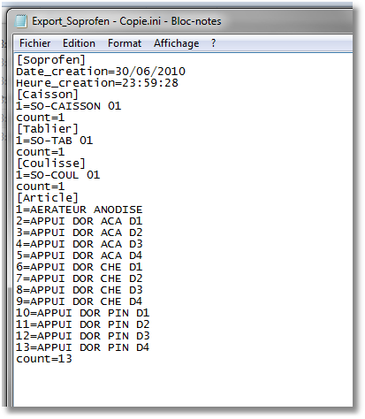

A message warns the user in case of successive exports, if files already exist into the target directory.
A complete roller shutter data export (roller Boxes, Curtains, Guides and Articles) may be done using checkbox “Complete export”, or a selective export when unchecked to obtain only what’s necessary.

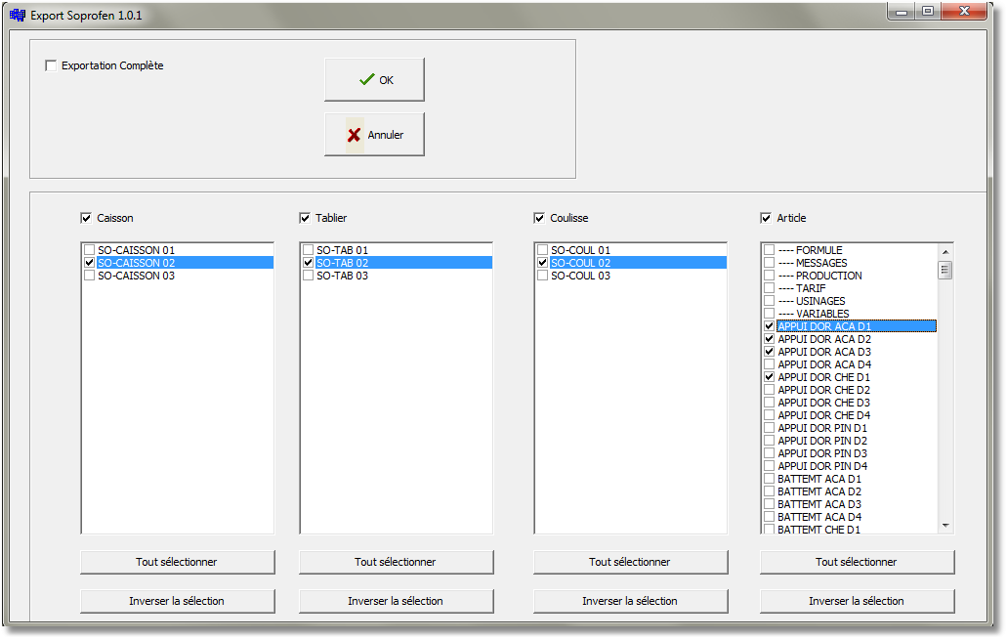

- The import process (menu Data | Soprofen | Import) will also retrieve files to import from the same subdirectory (set by “chemin” key).

In case of error, the result is traced into a log file, recorded into directoty “Import_Soprofen_Log\ Import_Soprofen_Log.log“ of the base directory.
A line is created here when one article to be imported does not correspond to a known supplier code, as set into WinPro.ini file.

Questions from composed glazings: Those questions are now printed onto customer documents (quotation, confirmation, ...), similarly to what’s existing for composed panels.

Version 8.04.023 | 27/06/2010

VAT code creation from WinPro and WinPro/D: When creating a VAT rate through menu Tools | VAR rate, an error message is now displayed when a VAT line is set with a blank code field.

Version 8.04.020 | 27/06/2010

Glazing pricing: It is now possible to set a negative price for a glass unit.

Compatibility between ventilators and composed glazing: Ventilators are now compliant with composed glazings. When a ventilator is used within a composed glazing, the ventilator is now correctly drawn and computed, as well as for DXF cut-throughs.

Addition to EDI for Glassver protocol: The choice for a customer number has been added when printing a glass order form with EDI protocol GlassVer.

Version 8.04.018 | 26/08/2010
Modified tables | Created tables
None | None

New markup variables: Two new local variables are available into data set up ; they are designed to alter by formula the extra margin defined into the various frames, within the Description tab the most often (Outer frame, sash frame, …).
Screenshot below shows the Description tab of an outer frame record.



TechnicalMargin = Local variable used to replace the extra margin set into the Description tab of the frame, usually (outer frame, sash frame, fittings frame etc).
It must be initialized into the first Profiles page of the frame imperatively, and will affect all tabs (profiles articles labour...).
Example :

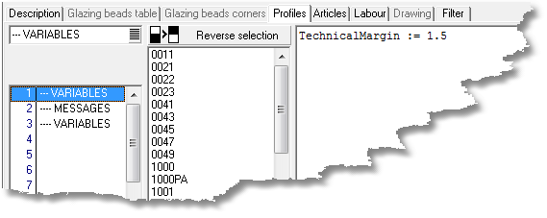

This code, initializing the variable into the first Profiles page of a Beads frame record, will replace the extra margin field set into the Description tab, and will affect all tabs.

ComponentMargin = Local variable used to replace the extra margin set into the Description tab of the frame, usually (outer frame, sash frame, fittings frame etc).
It must be set up into the formula of the component that should be marked up, and will not affect any other component, unlike TechnicalMargin.
Example :

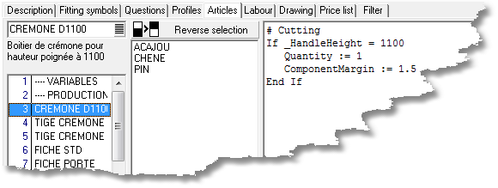

This code, initializing the variable within an Article page of a Fittings frame, will replace the extra margin field set into the Description page of this frame, marking this article up only, others elements are not altered.

Version 8.04.017

Details about composed glazing: Many fixes have been released for the composed glazing set up within this version. We also add new features that we hope you will appreciate. First of all, a reminder about data set up basis concerning composed glazing:
- Variable SupplierId is no more exclusively available at the glazing bars set up level. This variable usually returns the glazing supplier ID (useful when using the Glazings multi-supplier module combined with composed glazing set up).
- It is not allowed to consume a composed glazing within a composed panel, or within an existing composed glazing.
- When selling price is not calculated through a price grid into the Price list tab of the sash frame : the composed glazing is valued into a quotation with the content of its Main suppl. tab, cumulated to each component price.
- When selling price is calculated through a price grid into the Price list tab of the sash frame : the composed glazing is valued into a quotation with the content of its Price tab, cumulated to each component price.
- The status of boxes Do not use for cost/selling price, as well as the computation mode are relevant for composed glazing pricing (commercial, real cost)
- The glass order form is valued with cumulating the content of its Main suppl. tab along with prices of all components not excluded from the cost price.
- The glass order form prints the composed description string (the glazing base description will be used as default otherwise).
- The composed code and description will be displayed within the Informations tab of an order or quote (the base code and description of the composed glazing will be used as default otherwise).
- The Price tab of a glass leaf consumed into a composed glazing is not considered by WinPro during composed glazing price computation.
- The TechnicalMarkup variable defined into a dummy component rule will apply an additional markup coefficient. This mark-up will affect any component suiting conditions defined within the formula.
- The TechnicalMarkup variable defined into the 1st formula of the Glazing tab allows to apply an additional markup to ALL components consumed into the next tabs (eg : TechnicalMarkup := 1.1 to increase markup of 10%). This technical markup replaces the additional markup defined into the Price tab of the composed glazing, ONLY for components consumed into Glazings, Profiles, Articles, Labours tabs. As a consequence, the content of tabs Price and Supplier is not altered by this variable. This variable is unavailable for single glazings (not composed), and should be used into tabs Glazing, Profiles,…
- The ComponentMarkup variable defined into the formula of any component will apply an additional markup coefficient. This mark-up will only affect components where it is defined.
- The TotalThickness variable allows to modify by rule the default total thickness of a composed glazing. (This variable is also used for composed panel set up).
- The IntegrateWindowPrice variable allows the user to decide when the price of a given component has to be part of the wiindow or glazing price detail. The variable is null by default, which means components are part of the glazing price. This feature is important when you print the pricing details onto quotations or confirmations.

Note:
The IntegrateWindowPrice should never be used into the Glazing tab. WinPro will automatically affect prices of glass leaves to the composed glazing price.

- About code set up of questions for composed glazing, variables FillingIndex and SashIndex are not available when the glazing is defined « by default » into the window, through the Window tab of the order :
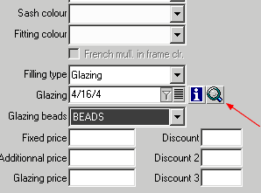
- When the composed glazing is input through the Sash tab of the order, only the SashIndex variable will be available for questions code :
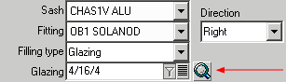
- Finally, when composed glazing is input through the context menu ‘Change glass’ displayed when right clicking onto a filling from the Sash tab of the order, both FillingIndex and SashIndex will be available for questions code :
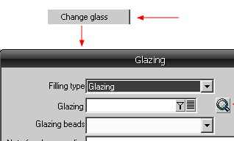

Sample of rule consuming a glass leaf with a 50% mark-up :
ShrinkShape (1, 5)
DimA := ShapeDimA [1]
DimB := ShapeDimB [1]
DimC := ShapeDimC [1]
DimD := ShapeDimD [1]
DimE := ShapeDimE [1]
DimF := ShapeDimF [1]
DimG := ShapeDimG [1]
DimH := ShapeDimH [1]
DimI := ShapeDimI [1]
DimJ := ShapeDimJ [1]
DimK := ShapeDimK [1]
DimL := ShapeDimL [1]
Orientation := ShapeOrientation [1]
FillingShape := ShapeType [1]
Quantity := 1
ComponentMarkup := 1.5

Price list creation from libraries: Inspiring from all your feedbacks, usefull changes have been done to enhance usage of price list creation from libraries :
- Chosse now the currency used at the print dialog level.
- Price list may be computed now based onto fabrication or masonery dimensions.
- Valuation options are now available to include or not the roller shuytter or even glazing price into the computation line.
- Choice between paper or file output through ASCII format file, recorded into a new subdirectory labelled Tarifs.

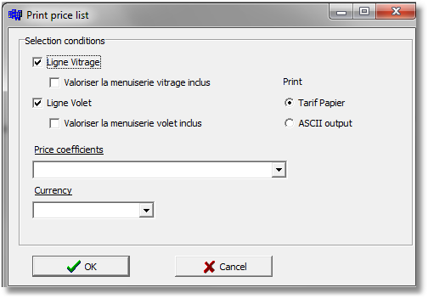

Version 8.04.014 | 27/06/2010

Problem fix for EDI protocol Sprimoglass: The write of the glazing location into the EDI file for Sprimoglass protocol is now similar to the design location code.

Before bug fix:
1.1.2 for window 001
Afetr bug fix:
001.1.2 for window 001

Polish codepage under WpReport: Characters from Polish codepage may now be displayed using WPReport, with the old and the new designer interface.

Version 8.04.007 | 27/06/2010

Validity for false arches colours: When the selected colour of a false arch is not allowed, an error message is now displayed for the input user.

Filter onto sash frames list using multi sashes for fitting frame feature: Using this feature (« Quinc Multi Ouvrant = 1 » within [System] section, refer to release note 8.03), the sashes list is now filtered and only lists sashes belonging to the same system, instead of listing all sashes from all systems.

Version 8.04.006 | 27/06/2010

Window creation into an order: When successively creating designs into an order, WinPro retrieves by default RAL colours from the first window of the order, and applies it to the following window by default.

New feature for stock resetting: You may now reset the stock values for a single stock location at a time. Moreover, when no stock location is detected at WinPro’ startup, and when the Stock Management module is enabled, a stock location record is automatically created.

Version 8.04.000 | 27/06/2010

Discounts and fixed price: When a price is fixed for a given design, only the main discounts for the window are now available, discounts for glazings or roller shutters are no more displayed.
When creating a single roller shutter, discounts for roller shutter will only remains available.

Fitting milling: Due to a bug fix concerning millings from fitting frames and variable sections (outer frame, sash frame, ...), a checkbox is now available into the Milling tab of the systeme record.
Tis box labelled "Fitting milling” is automatically checked when creating a new system, it is recommended to leave this box checked for any new system.

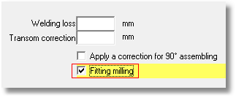

Version 8.04.xxx

New WPREPORT functions: The RemoveDir (Path : string) : Boolaen function is suitable when you want to remove a specified directory. It returns True in case the operation is correctly done, False otherwise. The directory must be empty to be deleted.
- Path corresponds to the path of directory to delete.

Example :
RemoveDir (‘c:\doc’)

This code will delete directory ’c:\doc’, if exists an dis empty.

The BrowseDir (Path : string) : string function allows to browse the content of a specified directory. It returns a string with the list of browsed elements.
- Path corresponds to the path of directory to browse.

Example :
Var
FileList : string ;
FileListTxt : string ;
Begin
FileList := BrowseDir (‘c\\doc\\*.*’);
FileListTxt:= BrowseDir (‘c\\doc\\*.txt’);
End

This code stores into a string variable FileList the content of directory ’c \\doc’, whereas the FileListTxt variable is set with the list of text files from the same directory.

The FileExists (FileName : string) : Boolean function checks if a specified file exists or not. It returns True when the file exists, False otherwise.
- FileName corresponds to the name of the file to be checked.

Example :
Var
Existfile : Boolean ;
Begin
ExistFile := FileExists (‘c\\doc\\File.pdf’);
End

This code stores into ExistFile variable if the file ‘c\\doc\\File.pdf’ exists or not.

The DeleteFile (FileName : string) : Boolean function allows to delete a specified file. It returns True in case the operation is correctly done, False otherwise.
- FileName corresponds to the name of the file to be deleted.

Example :
Var
DeletedFile : Boolean ;
Begin
DeletedFile := DeleteFile (‘c\\doc\\File.pdf’);
End

This instruction will delete file ‘c\\doc\\File.pdf’ and will return the result of the deletion int variable DeletedFile.

The FileLength (FileName : String) : Integer function is designed to return the size of the specified file, into kilo-bytes (KB). It returns an integer value corresponding to the file size.
- FileName corresponds to the name of the file to evaluate.

Example :
Var
FileSize : integer ;
Begin
FileSize:= FileLength (‘c\\doc\\File.pdf’);
End

This instruction will store into variable FileSize the size of file ’c \\doc\\File.pdf’, into KB.

The CopyFile (SourceFileName : string ; TargetFileName : string) : Boolean function is used to copy a source file toward a target file. It returns True when the copy is correct, False otherwise. If the target file already exists, it will be overwritten without confirmation.
- SourceFileName corresponds to the source file name to copy.
- TargetFileName corresponds to the target file name.

Example :
Var
FileCopied: boolean ;
Begin
FileCopied := CopyFile (‘c\\doc\\File.pdf’, ‘c\\doc\\File2.pdf’);
End

This code copies file ’c \\doc\\File.pdf’ toward target file ’c \\doc\\File2.pdf’, and returns the result into variable FileCopied.

The Execute (S : string; T : string; W : boolean) : Boolean function is designed to execute a specified extern program from within a WPR report. It returns True in case the operation is correctly done, False otherwise.
- S corresponds to the name and the path of the extern program to execute.
- T corresponds to optional settings and command line switches for this program.
- S indicates if the execution is done with minimized dialog (True) or not (False).

Example :

Var
ProgExecution : boolean ;
Begin
ProgExecution := Execute('c:\winpro\winpro.exe', '/WPR', false)
End

This instruction will start WPR program, and will return True into variable ExecutionProg if WPR has correctly start up.

RAL offcuts for WinPro/D: new key into settings table from WinPro/D activate RAL offcut computation in order to add the RAL offcut value to the order total. Previously, RAL offcuts were systematically added to the order total.

[System]
Sans Chutes Ral = Enables (0, default value) or disables (1) RAL offcut computation onto WinPro/D’s quotations.
Modification into table DetLot: When optimizing a customer order containing additionnal profiles supplied (Profiles tab of the order), the POSITION field will be set to ‘ * ‘ for such profiles, aas they have no defined side position.
New WPREPORT function: The function DxfDrawing (Picture : string ; Code : string; Type : string; Width : Integer ; Height : Integer) allows to draw a WinPro DXF drawing into a report;

- Picture correspond to the name of the picture object created into the report
- Code correspond to the code of the DXF
- Type correspond to the type of DXF record. If set to A or a, a DXF matching the code will be searched into the article table, in case of another value the code will be searched into DXF table
- Width correspond to the drawing width into pixels
- Height correspond to the drawing height into pixels

If a too great value is input for the picture object, for width and height, the drawing will be limited to the size of the picture object defined into the page.

Examples :

DxfDrawing ('Picture1','1130','1',100,180)
This instruction displays into Picture1 object a Dxf indexed into the Dxf table

DxfDrawing ('Picture1','1130','A',100,180)
This instruction displays into Picture1 object a Dxf indexed into the Dxf table

Machine driver link with WPR: With versions 8.0.4.017 and 8.1.0.8 or earlier, the user will have the ability to link a WinPro saw either to a classic DLL machine driver, or a WPR made driver, using section [SAW].
Syntax:
For classic DLL driver links, the syntax remains unchanged
For a WPR machine link, the syntax would be :

[Saw]
WINPRO_SAW_NUMBER = REPORT_CODE;REPORT_DIRECTORY;PRINT
Où
WINPRO_SAW_NUMBER correspond to the saw number as defined into WinPro.
REPORT_CODE correspond to the RPT file name of the report used for the link.
REPORT_DIRECTORY correspond to the path to the RPT file containing the report to use as a link. When the report is not existing into the database, it will be automatically imported from this location. When this value is not set, the RPT file will be searched into WinPro base directory.
PRINT enables (1) or not (0) the printing of a document associated to the machine link.
WinPro will transfer to the link report the production batch number, usable into queries, through variable :job, along with the saw number through variable :saw.

Examples
1 = SAWV1;C:\drivers WPR\;1
The SAWV1 report, located into the directory C:\drivers WPR\, will be executed, with a printing of a WPR report.

When an update is received for the link, simply modify the [Saw] section and place the RPT file into the appropriate directory.

1 = SAWV2;C:\drivers WPR\;1

Customized menus for WPREPORT reports: This feature allows to created your own menu entries for customized reports designed with WPR. Those sub-menus will appear below the Reports menu. Add the following keys into the settings table:
[Reports]
Count = Number of customized reports (number of sub-menu entries, from 1 to 10, integer format I).
n = Code of the WPR report number n (character format S).
n:description = Description of the report number n, as it twill be displayed through the Reports menu (character format S).
Example :
Count = 1
1 = ART_DET
1 :description = Filtered article list

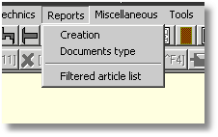

WPREPORT under command line: You may run WpReport program using a command line instruction, or through a batch file (*.bat). You also may run a report without running WinPro, with the following syntax :

WinPro /WPR@Username:Password Report_Code
This instruction runs the WPR Designer. The Username field corresponds to the WinPro user code (optional). The Password field corresponds to the password associated to the user account. When the account password is not set, or for account without password, the standard login dialog will be displayed at start up. The Report_code field should be set with the code of an existing WPR report (optional, the report should be adapted to a stand alone use without settings).

WinPro /WPRS@Utilisateur:mot_de_passe
Cette ligne lance le dialogue Documents type, accessible depuis le menu Rapport | Documents type de WinPro, mais sans lancer WinPro. Le champ Utilisateur correspond au code utilisateur WinPro (optionnel). Le champ mot_de_passe correspond au mot de passe du compte utilisateur. Si le mot de passe du compte n’est pas précisé, ou que le compte n’a pas de mot de passe, la fenêtre de login standard de WinPro apparaîtra.
WinPro /WPRS@Username:Password Report_Code
This instruction runs the Documents type dialog, usually accessed through WinPro’s menu Reports | Documents type, but without running WinPro. The Username field corresponds to the WinPro user code (optional). The password field corresponds to the password associated to the user account. When the account password is not set, or for account without password, the standard login dialog will be displayed at start up

Examples:
WinProD /WPRS
This instruction runs the configuration menu for the printing mode of documents within WinPro/D.

WinPro /WPR
This instruction runs the WPR designer, with the standard WinPro login dialog.

WinPro /WPR@Administrator:admin
This instruction runs the WPR designer, for the user of code Administrator, with password admin.

WinPro /WPR@Administrator:admin LISTEART
This instruction executes the report code LISTEART directly, for the user account Administrator, with password admin.

Note : WinPro/D may also run reports through a command line instruction, and modify the printing modes for the documents (with sufficient access rights). For this, simply replace the key word WinPro with WinProD at the beginning of the line. Nevertheless, WinPro(/D) will always be loaded into memory, but it is not executed.

Attention!
For all those command lines : the code of the called report should NEVER contain any space character !

WPREPORT access control: New variables are available for WpReport, allowing the users to define easily the access from WPR to the mySQL database. Those variables may be set into the designer, at the query designer level.
Two access method are possible for WPR toward a mySQL database, through ODBC (with appropriate mySQL driver), or through a direct connexion to mySQL server.

Connexion through ODBC :
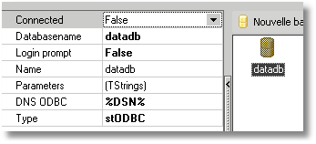
Type of connexion : stODBC
DSN ODBC : %DSN%
Parameters : 2 possibilities :
- %AUTOLOGIN%
or
- user name = %LOGIN%
- password = %PASSWORD%

The %DSN% variable is here automatically replaced with the correct mySQL connexion data (server name + schema name). Note that when an ODBC connexion to a mySQL serve ris identified, WPR automatically uses the mySQL driver.
The %AUTOLOGIN% variable is replaced with connexion data on the mySQL database, as set at WinPro’s login dialog (user name + password for mySQL at the startup). This variable is used alone into the settings window.
The %LOGIN% variable is replaced with the mySQL user name used by WinPro at startup. It is also possible to use the user name field with a fixed value for the mySQL user granted.
The La variable %PASSWORD% variable is replaced with the mySQL password used by WinPro at startup. It is also possible to use the password field with a fixed value (Note anyway that the password and above user name fields, when set as fixed values, are readable by any WPR user granted !).

Considering that a direct connexion to mySQL server is always quicker than via ODBC, this last method would be less efficient.

Direct connexion to mySQL :
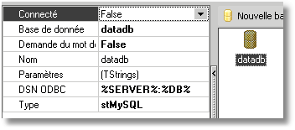
Type of connection : stMySQL
DSN ODBC : %SERVER% :%DB%
Parameters : 2 possibilities :
- %AUTOLOGIN%
or
- user name = %LOGIN%
- password = %PASSWORD%
- port = %PORT%

The %SERVER% variable is automatically replaced with the mySQL server name defined for WinPro at
startup.
The %DB% variable is replaced by the mySQL database name defined for WinPro at startup.
The %AUTOLOGIN%, %LOGIN%, %PASSWORD% variable are used as described above.
The %PORT% variable is optionally replaced with the port number of the mySQL server, when different from the default value (port=3306), as defined at WinPro’ startup. A fixed value may also be set for this setting.

Note : Those access methods to the mySQL database are available for a report in use, those variables do not allow to preview a query result through the WPR query browser.

Printing options for price lists from libraries (module): The printing dialog for price lists from libraries for designs and roller shutters (menu Orders | Libraries) has been enhanced with some new features. This dialog is raised with using the Print price list button from a library.

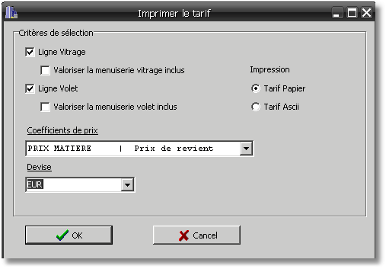

The Ligne Vitrage checkbox will create a specific line for the price of the glass units separately. When unchecked, no additional line for glazings price is created.
The Valoriser la menuiserie vitrage inclus checkbox will include the price of the glazings into the price line for the window. When unchecked, the price line for the window is computed excluding glazings price.
The Ligne Volet checkbox will create a specific line for the price of the roller shutter separately. When unchecked, no additional line for roller shutter price is created.
The Valoriser la menuiserie volet inclus checkbox will include the price of the roller shutter into the price line for the window. When unchecked, the price line for the window is computed excluding roller shutter price.
The Price coefficient combo allows the user to select a price margin among the list for this price list computation.
The Currency combo allows the user to select a currency for the price list computation among the list.
The Paper output checkbox will raise the standard Window’s dialog for printing.
The Ascii output checkbox allows to save the price list computation result into a text file. This file may be renamed with a CSV file extension, in order to be opened using a dedicated software supporting this format (MS Excel, OpenOffice suite…). The field separator used into this file is a tabulation TAB.

Enhancement for the Edit settings tool feature: The Tools | Edit settings feature, used to modify values of sections and keys of settings table straight into the interface, has been enhanced.
You may now create your own keys and sections, using the pop up menu reached with a right click of the mouse into the section list.
Highlight a section in the list (not a key !), and use the « Add section » menu entry to create a new section along with one single key at the same time.
Highlight a target section, and using the right click pop up menu, create a new key with the « Add new key » entry into the selected section. The use buttons Save and Record to save your changes.
The utility shows also a description for each key (if exists) into a new pane. Those descriptions may be customized, then you can add, remove or complete a description for a chosen key, even into customized languages.

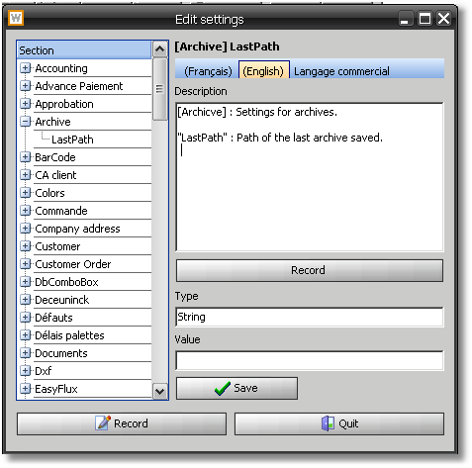

You may modify the text into the Description field, and save the changes using the Record, then the Save buttons.
Some tabs are shown above the description field, leaving the user choose the required language to create/modify/view the key’s description.
Descriptions are stored independentely into separated files for each visible languages (variable length text format), named « sStrings.xxx » files (xxx is the language code), into a sub directory Trad of the base directory.
Those files are commonly supplied with the program versions into both base languages French and English.

New WPREPORT function: The function GetWindowsRect(DialogPage : string ; Var x,y : integers) : integers returns height (x) and width (y) dimensions of a DialogPage object of WPR.
- DialogPage is the name of the DialogPage object created
- x correspond to the height value
- y correspond to the width value

Example :
// A report contains a dialog page object named 'DialogPage1' with a button
// Clicking the button show a message box with height and width values of the dialog box object

procedure Button1OnClick(Sender: TfrxComponent);
var
x,y : integer;
begin
GETWINDOWRECT('DialogPage1', x,y);
showmessage(x);
showmessage(y);
end;

Filters on Commercial Region and Commercial Salespoint for WinPro/D: Two new filters have been added to WinPro/D, allowing a user to filter on lists of orders and lists of customers or prospects during order input. The user would only be able to list orders/quotes, or even customers/prospects corresponding to the salespoint and/or region assigned to him.
To create those elements into WinPro/D datas, 2 new menus have been created, Data | Commercial region and Data | Salesman.

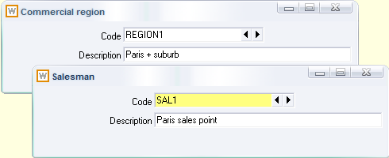

At the user set up level, you may select the region and/or sales point to affect to the selected user.

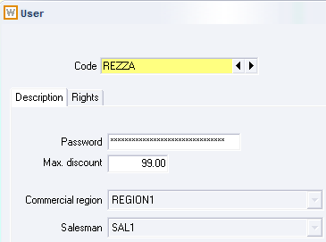

Finally, a region and/or sales point may be assigned to a customer record (Relationship tab) or a prospect record (main dialog).

Filtering rules
For a user with no region or salespoint set, the user would have a full access to the whole job and whole customer file into WinPro/D database.
For a user with a region set but no salespoint, the user would be able to list all orders and all customers/prospects assigned with the same region.
Finally, the most « restrictive » filter arises when a region AND a salespoint is set for the WinPro/D user. This user would then only be able to list orders and customers from the same region AND with the same salespoint asigned.
Note : orders are filtered based on the customer or prospect code set into the order itself

File compression for e-mail attachements using WinPro or WinPro/D: A compression may be enabled for the export files Winpro(/D).may have to generate. This compression may avoid various programs (antivirus or firewal from provider, local mail client, etc…) to alter the text structure of the document.
To use this compression, add the following information into WinPro.ini file (or settings table for version 8, integer format I):
[System]
ZipWpx = 0 No compression (default behaviour)
= 1 Compression for files in attachment

New Glazing dim. Rounding tab available into the supplier file. This tab gives access to a formula for surface calculation of glazing for that supplier. The result will be stored into a new RoundedSurface variable. If the variable is not null, WinPro will use it to compute the price of the glass unit, otherwise the dimensions computed by the program will be kept.

Changes on WinPro’s licence file format: WinPro’s licence file changes of format with this version. From now on, the program will require a WinPro.lc2 file instead of a WinPro.lic file !

Installation of WinPro/D Foxpro: From this version of WinPro/D, it will be necessary to install the program using sufficient administrative privileges for Windows.

If you use a Windows administrator account to install WinPro/D Foxpro onto the target machine, you are not concerned by the following information

Otherwise, an error message is now displayed in case you are not logged as Administrator when installing WinPro/D.

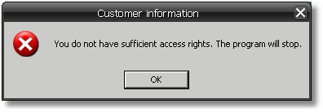

If you meet this dialog when running WinPro/D, you haven’t got enough installation privileges onto the machine !

In order to avoid such troubles when deploying, whatever the system is (XP, Vista or Seven…), proceed as follows :

- Use an Administrator level account for Windows. Please contact your computer supplier if you haven’t got those logon settings, otherwise installation is impossible.
- Install the package « Microsoft Visual C++ redistribuable » onto the machine. This package is supplied with any version of WinPro, and is named « vcredist.exe ». It is better to install the version supplied by Quadrature. The installation of this Microsoft package also requires administrative privileges onto the machine.
- Install the Sentinel dongle driver if required. It is available onto the base directory of our FTP server.
- WinPro/D may be launched at this stage. Nevertheless if you meet the below error dialog

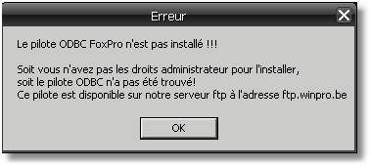

it will then be necessary to install the ODBC FoxPro VFP driver onto the machine, still using administrative privileges for Windows.
Indeed, some printings have been redesigned under WPReport module for WinPro/D, the ODBC FoxPro driver is then necessary to be able to print those.
You may easily find this driver onto our FTP server, or at url http://msdn.microsoft.com/en-us/vfoxpro/bb190233.aspx.
Some listing documents may be impossible to print without this driver installed onto the system.

Points 1, 2 & 3 are concerning WinPro as well as WinPro/D, using FoxPro or mySQL database format. However, point 4 only concerns users of the WinPro or WinPro/D programs using a FoxPro database

We insist on the fact that if you install WinPro/D (or WinPro) using sufficient administrative privileges onto the target machine, and when all needed components supplied are correctly located into the installation directory, all those processes are done automatically !

Compatibility 7.2 | 7.2.76

Colour management using false arches: False arches listed for the user during order input are now filtered onto appropriate settings, instead of simply showing an error message when validating.
A false arch must fit the following requirements to be used in a given desing:
- The window system must have been allowed into the list of systems of the false arch set up.
- The false arch must be created with a line of valuation setting the colour used for the window
or
- The false arch must be created with a line of valuation setting no colour code into the corresponding field

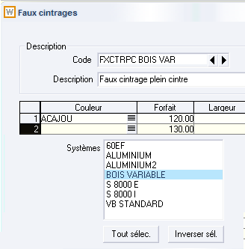

The above false arch will be listed for the BOIS VARIABLE system only, when a design with ACAJOU colour is created (valued line with colour code), and also when a design of any colour of the system is created (valued line without colour code).

Version 8.03
Compatibility 7.2 | No

Version 8.03.035 | 27/06/2010

Enhancement concerning document export toward tables: Some enhancements related to the export of documents to table feature concerning quotation (detailled, simplified, with no dimension, ...) listed below:
- Into an order, when box “Discount per window” is checked and a discount for installation is set, gross prices will be exported to table Art, concerning Articles, Profiles, Bent Sheets or Installation articles.
- Into an order, when a “Discount per window” is set, no “Hidden discount” and a discount for installation, fields PCREMPOSE and VALREMPOSE from table CDE are now fullfilled.
- Into an order, when no “Hidden discount” is set along with no “Discount per window”, and with a discount for installation, installation articles from the Installation tab are exported with net prices into table Art.

Version 8.03.032 | 27/06/2010

Export of WinPro.ini decimal separator: When table Settings is exporte to a WinPro.ini file through menu Tools | Export to WinPro.ini, WinPro automatically replaces the decimal separator int the file with “ . “ (point), this to avoid compatibility problems when importing the file into a database.

Version 8.03.027 | 27/06/2010

Export tables and window set with roller shutter: In case of window set including a roller shutter, question from the roller shutter are now also exported into DET table.

Version 8.03.025 | 27/06/2010

New module Import Glazing (.xls): This new module allows to import a list of glazings that will be automatically created into the database from a formatted Excel file.
This feature is available at menu Tools | Import glazing (.xls).
The dialog shows an browser to select the appropriate Excel file.
Data from this file should be formatted as follows:
- The first line of the file must correspond to the field names from tables Vitrage and FournVit.
- The first field must be the CODE field.
- For any line from table FournVit, a column "AF" should be added, followed by the NUMERO field as well as others fields from FournVit table.

In fact, records from FounVit are put in line for each glazing.
We obtain : « Fournvit for glazing code 1 supplier 1 + AF + numero + Fournvit for glazing code 1 supplier 2 etc... »

Example:
CODE |AISANCE |... |AF |NUMERO |... |AF |NUMERO |... |
4/15/4 |4 | | |0 | | |1 | |

Once the file is selected with the browser, use the “Update” button to import.

Unexisting supplier codes are created automatically.

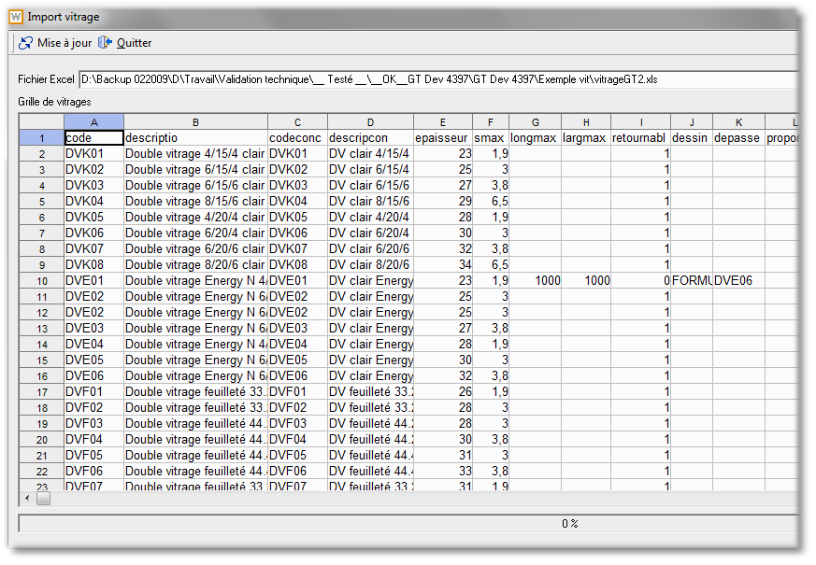

Version 8.03.021 | 27/06/2010

Fields deleted into pannel tables: The fields Fourniss and BSupplFft from table PannDeco, and field BSupplM2 from table Panneau are now dropped from table, as they are now out of date.

Version 8.03.015 | 27/06/2010

Printings for additional elements: Prices for additional supplies within an order (tabs for Articles, Profiles ...) are not detailled anymore onto quotations when the order price is fixed manually.

Version 8.03.014 | 27/06/2010

Guides and final blades colour into a roller shutter: New checkboxes available within Curtain and Guide set up dialogs, for roller shutters included into a window.

- A new checkbox into the Description tab of guides set up dialog, giving the ability to allow the list of outer frame possible colours into the guide colours list.
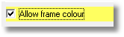

- A new checkbox into the Description tab of the curtains set up dialog, giving the ability to allow the outer frame colours into the curtain final blade’s list of colours.
- A new checkbox into the Description tab of the curtains set up dialog, giving the ability to allow the guide colours into the curtain final blade’s list of colours.
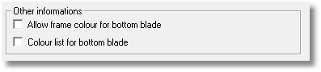

Information about Multi-sashes for fitting frame feature: When toggling from a standard data set up to a set up using this multi-sashes for fitting frame feature (release note 8.03), the base sash frame normally sets for the given fitting frame is now defaultly affected to this fitting frame.

Additional clearance for glazing: You may assign an additional glazing clearance from the Description tab of the Sash frame.
This additional clearance value is now cumulated to existing clearances contained into global variables for clearances, _FillBottom/Top/Left/RightClearance, corresponding to clearances values computed for each side of the glazing.

Version 8.03.007 | 27/06/2010

New fields into export tables for documents Art, Cde & Fen: Changes have been made into exported documents :

Art table
1. New field PVNET added, value 0 or 1, depending on the nature of the selling price computed (net or gross) and stored into field PVTotal.
2. Material discounts are now exported into fields REM1/2/3, when additional supplies are exported into table Art.

Cde table
1. A new field REMREPERE added, corresponding to DETREMISE field from table Commande. This field is worth 1 when box “Discount per window” is checked, zero instead.
2. A new LANGUE field added containing the language code used when exporting.

Fen table
1. A new PVNET field added, value 0 or 1, depending on the nature of the selling price computed (net or gross) and stored into fields PVTOTAL, PVVOLET, PVVITRAGE, PVCHASSIS.

This will be used prior to any setting defined into Winpro.ini/Settings.

Version 8.03.xxx

RAL offcuts for WinPro: A new key into settings table for WinPro allows the RAL offcut computation to be done when the order is recorded.

[System]
RAL = Enables (1, default value) or disables (0) RAL offcut computation when recording the order.

Archiving by moves (using module MYSQL) : In case your database is under mySQL format, you should add the following keys into settings table, in order to use the feature.:
[Archive DB]
User = Administrator => WinPro user (string S)
DB = ArchiveDB => Name of the mySQL database (string S, lower case imperatively)
Host = ServerName => Name of the mySQL server (string S, lower case imperatively)
Port = 3306 => mySQL server port number (integer I)
The archive database should be the same structure as the original database, and should contain the WinPro user recorded into settings table as shown above.

Profile wastes valuation: Winpro do not value wastes for a profile when no colour code is mentioned inti the bar lenght tab of a profile record.
That’s the reason why the checkbox Watste val is now greyed and unchecked systematically when no code is set into the colour column.

Warning message on batching: When using the quick order selection feature during batching stage of production line module (GLP module), a new message warns the user that a particular design has been computed as failed.

New WPREPORT function: The function RecordCount(Query : string) : integer returns the number of records for the defined query. Returns -1 in case of error (invalid or already opened SQL query)

New WPREPORT function: The function EditSelectAll(Edit box: string) allows to highlight the text into an edit control object TFRXEditControl.

New WPREPORT function: The function Translate(ID : string; Language code: string) : string returns the translation of a field from the program interface or from an internal document, contained into files labelled strings.xxx.
- ID is the name of the key to be found into the string.xxx file
- Language code is the code of the language to look for into the file string.xxx
This function is only suitable for fields from the interface or from printed documents; it is not suitable for user defined set up elements (like outer frame or sash frame description for instance). This function, used along with below TransData() function, allows to create multilingual reports using WPR.

Example:
Translate('DOC_TVA','ENG') returns the translation of the field from the interface or document labelled DOC_TVA, into the language of code ENG. WinPro will look for a corresponding entry into the file strings.ENG. In case none is found, a corresponding entry will be searched into the substitution language (see module for language management xstring.exe).

New WPREPORT function: The function TransData(Table : string ; ID : string ; Language code : string ; Description : string) : string returns the translation of a user defined labelled created into the database, and stored into files called Tra.xxx.
- ID is the name of the field to be translated
- Table is the table containing the field to be translated
- Description is the value of the field to be translated
- Language code is the language code used to search the translation (file Tra.xxx, where xxx is the language code)
This function is only suitable for user defined data set up elements like outer frame or sash frame description ; it is not suitable for translating fields related to the program interface or documents. This function used along with the above mentioned Translate() function, allows to create multilingual reports using WPR.

Example:
TransData('Question', 'Descriptio', 'ENG', 'Handle height') seek into table Question field Description a corresponding value for 'handle height'. When found, WPR look for a corresponding value into the Tra.ENG file, for the ENG language code (the file is created when the question is translated into the ENG language code, using menu Miscellaneous | Translations).

New WPREPORT function: The function GetCursorPos(Variables X,Y : integer) returns the absolute coordinates of the mouse cursor from the screen (and not from the current in use WPR dialog).

New WPREPORT function: The function WindowDrawing(Picture object : string ; Order : string ; Window : string ; Width : Integer ; Height : Integer ; Dimension : Boolean ; Glazing dimension : Boolean)
allows to draw designs elevations straight, without the need of an external EMF file.
- Picture object is the name of the picture object into WPR designer
- Order is the order code of the design to be drawn
- Window is the code of the concerned design of the order
- Width is the design width
- Height is the design height
- Dimension is a switch enabling dimension lines onto the design drawing (True=enable)
- Glazing dimension is a switch enabling dimension lines onto the design drawing for glass units only (True=enable)

Example:
WindowDrawing('Picture1', 'TESTDESS', '001', 1000, 1000, True, False) this instruction draws into picture object Picture1 of the report, the drawing is for design number 001 from the TESTDESS order, having dimensions 1000 W x 1000 H, with drawing design dimension lines but not the glazing dimension lines

New WPREPORT function: The function Browse(Key : string ; Table : string) : string allows to list values of a given field from a table without the need of a SQL query.
- Key is the name of the field to browse
- Table is the table containing the field.

New WPREPORT function: The function CallReport(Report name : string) allows recursive call of WPR reports from an existing report.

New WPREPORT function: The function ReadSettingFloat(Section : string ; Key : string ; Default : double) : double, as well as ReadSettingInteger(Section : string ; Key : string ; Default : integer) : integer and ReadSettingsString(Section : string ; Key : string ; Default : string) : chaine afford a direct read of a key into settings table, without need of a query. They respectively return the required key for formats floating points, integers and strings.
- Key is the name of the searched key
- Section is the section of the settings table including the key
- Default allows to fix a default value in case no value is found for the search into settings table.

New WPREPORT function: The function WriteSettingFloat(Section : string ; Key : string ; Value : double), as well as WriteSettingInteger(Section : string ; Key : string ; Value : integer) and WriteSettingsString(Section : string ; Key : string ; Value : string) afford the user to write straight values into settings table without the need of a query (respectively for formats floating points, integers and strings).
- Key is the name of the searched key
- Section is the section of settings table containing the key

New WPREPORT function: The function SetCharset(Charset : integer) allows to define a default character set to be used by the designer.

New WPREPORT function: The function SetDecimalSeparator(Format : string) allows to set a specific character as decimal separator for the displayed numbers.

New WPREPORT function: The function SetThousandSeparator(Format : string) allows to set a specific character as thousand separator for the displayed numbers.

New WPREPORT function: The function SetGlobalFont(Name : string ; Size : integer) allows to set a default font for the whole report.
- Name is the default police name (ex. ‘Arial’)
- Size is the default police point size

New WPREPORT function: The function DestockagePosteAtelier(Spot: string ; Order : string ; Window : string) allows to remove from stock the articles associated to the defined production spot.
- Spot is the code of the concerned production spot
- Order is the order code within WinPro
- Window is the design number inside the order
Based on those 3 settings, WinPro will check the articles of the design. If associated to this production spot, those articles will be removed from stock.

Fields added into export table cde, fen et art, indicating when prices are stored as net prices (PVNET field, hidden discount checkbox).

Comments added to licence files (WinPro.lic): Comments are now available into licence files for version 8. To use the feature, simply use a dies ' # ' character at the beginning of the line. Licence files are now generated by default with a comment showing the customer name.

WinPro Light, menu name change for menu Confirmation handling | Print confirmations, renamed as Customer order form.

System filter for false arches: A new dialog into the false arches set up allows the user to filter the use of the false arch by system.
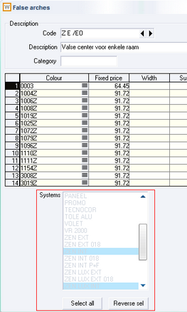
Multi sashes fittings frame: You may now assigned a same fittings frame to multiple sash frames, as long as the fittings frame set up is compatible with all associated sash frames. To enable the feature, add the following key into settings table, format integer I:
[System]
Quinc Multi Ouvrant = 0 one fittings frame for one sash frame, current behaviour (default value
= 1 multi sashes fittings frame

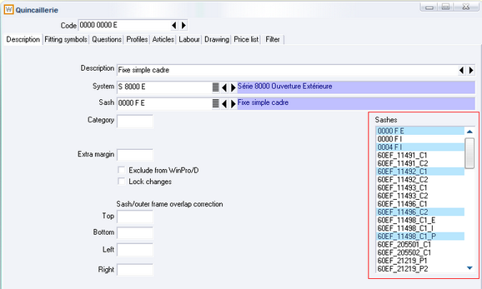

New global variable _VATRate: This new variable will be available at the beginning of the computation, and returns the value of the VAT rate used for the order.

Optimization for special window: A new checkbox into system set up allows a user to optimize orders as soon as the Confirmations handling | Validate confirmations (technical validation) stage is passed, with avoiding usual steps of the process. For running such an optimization, use the menu Production handling | Optimize special windows.

Optimization separated for transoms: A new feature into Utilities | Preferences dialog, Optimization tab, enables a checkbox into the Launch optimization dialog, and allows running a separate batching and optimization for transoms.
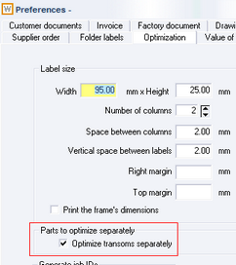

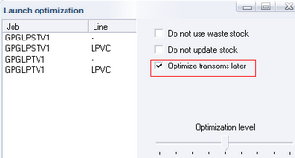
When launching a production batch, the user may uncheck the option « Optimize transoms later », transoms will then be optimized as usually. When the box is checked, the transoms will have to be optimized using Production handling | Optimize transoms menu. If the box is hidden, the batch is empty of transoms.

New variables for WinPro/D: A set of new variables specific to WinPro/D, _Discount1D (1st design discount), _ Discount2D (2nd design discount), _ Discount3D (3rd design discount), _RShutterDiscount1D (1st roller shutter discount), _ RShutterDiscount2D (2nd roller shutter discount) and _ RShutterDiscount3D (3rd roller shutter discount), is initialized by WinPro based onto discounts set by the user for windows in the order. They cannot be modified and are created in order to be able to test discount condition by window into a WinPro/D order.

Automatic prefix for batches using module GLP (production line management): In case your licence enable GLP module, 2 new keys into settings table define, by user, a customized prefix into batches numbering. To enable this, create as many keys as users::
[PrefixeLot]
%user%:Prefix = string format S, batch prefix code for this user
%user%:Number = double format D, sequence number of the next batch to be created

New checkbox into Actions tab of the order, Re print confirmations: This box allows printing again a confirmation from the Actions tab of the order, for an order confirmed but not optimized, or partially optimized. This document may anyway show price differences compared to the first confirmation printed.

Like filter for strings into a mySQL database: It is now possible to search for a sub string into a code or a description within WinPro. For instance, looking for string «urand » into name field of the customer file, you may type the instruction « %urand% » then click on the search combo. This may filter the list of customers with name containing the sub string « urand ».
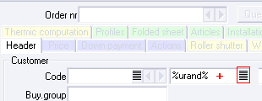

This is only relevant for a mySQL database format.

Version 8.02.048
Compatibility 7.2 | No

Brent coefficient (refer to release note 7.2.02) onto quotations: Addition of a new key into Settings table, enabling to apply the Brent coefficient onto quotations rather than only onto glass order form.
Onto quotations, the computation will be based on the method of procing used into the order, list or cost price.

[Glass]
BCvitrages = 0 The Brent is applied onto the glass order form only (default).
= 1 The Brent is applied onto glass order form AND quotation.

Version 8.02.xxx
Compatibility 7.2 | 7.2.72
Import / Export function for customers and orders using WinPro/D: You may now import or export the whole quotation and customers created into WinPro/D in a single step, using both new menus Utilities | Im/Export customer(s) and quotations. Both features share the same base directory.
« Printing correct ? » dialog for optimization documents: You may now disable this dialog with adding a new key into settings table, format integer I:
[Optimisation]
Confirm Print = 0 disabled
= 1 enabled (default value)

Compatibility 7.2 | 7.2.71

Automatic fixed price for an order: A new settings key (format double D) allow an automatic additional price to be added to the order total:
[Customer Order]
Forfait Auto = automatic additional price amount (zero by default)
Recomputation and price record dialog: 2 additional switches to control price recompilation and price record dialogs into an order, in case the order is modified or recorded again.
[Customer order]
Memo Prix = 0 WinPro asks if prices should be recorded again (current behaviour, default value)
= 1 prices are always recorded without acknowledgement
= 2 prices are never recorded

Recalc Prix = 0 WinPro asks if prices should be computed again (current behaviour, default value)
= 1 prices are always recomputed without acknowledgement
= 2 prices are never recomputed

Compatibility 7.2 | 7.2.58.2
Global management dashboard: This new feature is a visualization board of the customer orders with their respective statuses and properties from a same interface, without the need to browse the miscellaneous management menus.
The left hand panel offers a various set of filters, search and display options:
- Filters on date selection
- Display options depending on the user’s responsibility level (Commercial/Technical/Financial into green colour, Production into red, Delivering/Invoicing into yellow), as well as settings playing with the level of detail required
- Filters on order type or status, representative or delivery area
- Search options on orders according mark-ups, or for a specific order.
The right panel shows the order filtered list. This interface offers a comfortable view on information, and allows sorting features on clicking on various columns of the array. A given order code will be automatically opened when double clicking on it, as well as for a customer code.
The screen list may be printed at anytime using the appropriate Print button, with optionally setting up a zoom level for the document. You may finally export the screen list as an Excel file, using the button labelled XLS export.
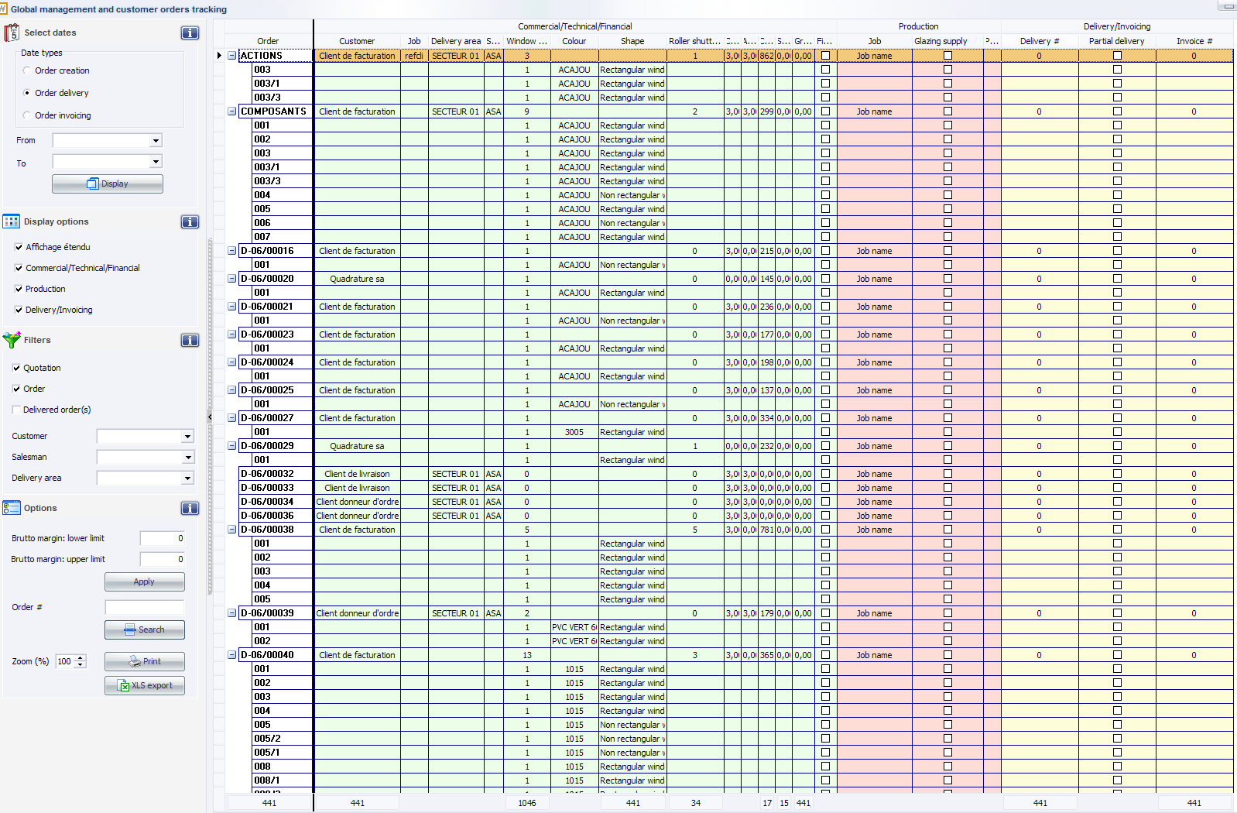

Compatibility 7.2 | Yes (partially)

Composed glazing: This new module is suitable to create your own glazing set using formulas instead of a list of fixed fields. Checking this box for a glass unit will move a list of fields into the new tabs activated, « Questions », « Glazings», « Profiles », « Articles », « Labours» and « Drawings». A filter for “Allowed colours” is also available. You may also program code and description fields of the glazing, using Composed code & description features along the tabs (filling macros).
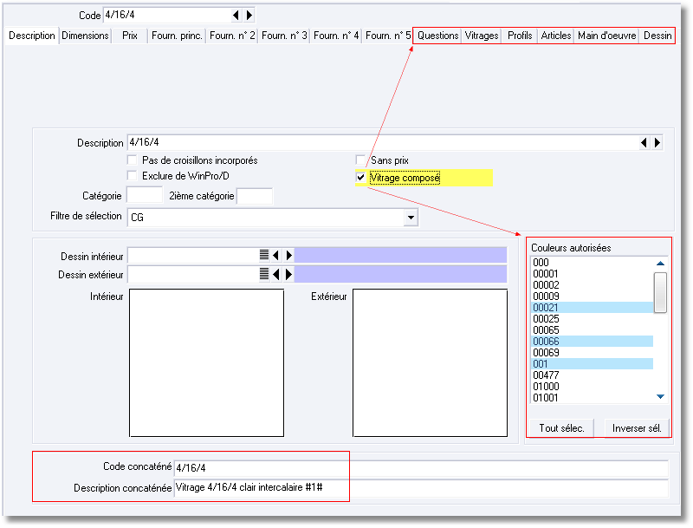
This module is similar to the composed panel module but with some variants. The syntax may also vary between versions 7.2 & 8 of WinPro.
Please refer to the general set up manual, CHM format, for details of use of formulas within those tabs (variables available, consumption rules, etc.).
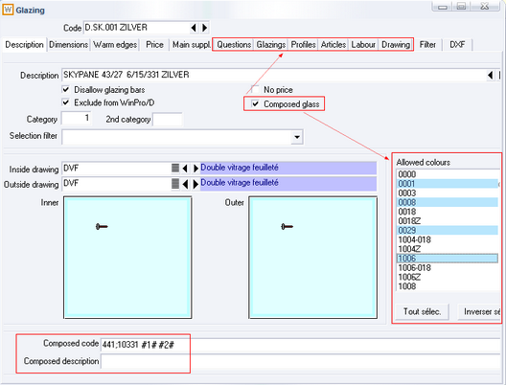
Sample of basic formula for composed glazing, Glazings tab:
# Common rule for the whole sheets
# Glass clearance
ShrinkShape (1, 3)

# Dimensions calculation, shape depending
DimA := ShapeDimA [1]
DimB := ShapeDimB [1]
DimC := ShapeDimC [1]
DimD := ShapeDimD [1]
DimE := ShapeDimE [1]
DimF := ShapeDimF [1]
DimG := ShapeDimG [1]
DimH := ShapeDimH [1]
DimI := ShapeDimI [1]
DimJ := ShapeDimJ [1]
DimK := ShapeDimK [1]
DimL := ShapeDimL [1]

# Shape & orientation assignation, if required
Orientation := ShapeOrientation [1]
FillingShape := ShapeType [1]

# Consumption
Quantity := 1

Attention!
It is not possible to use a composed glazing into a composed panel, both features are not compatible ! Only single glazings (not composed) must be consumed into composed panels!

Compatibility 7.2 | No

Additional sort column within browse dialog: The browse dialog for technical elements has been enhanced with a new sort column « Number » nearby « Category ». This field only appear when sequencing field « Number » is visible within concerned menus (transoms, fittings, sashes, peripheral profiles and outer frames). You need to set the key Numerotation List=1 at section [System] of table settings to enable the feature, as mentioned in release note 7.1.21.

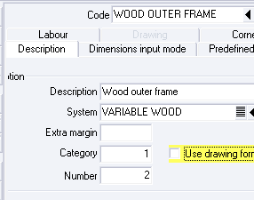

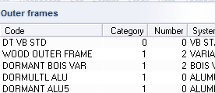

Price table from libraries: The old price list module has been rebuilt in order to enhance the functionalities as well as the interface, now integrated to design libraries feature, menu Orders | Libraries. Interface and feature have been completed, calculation now compute using most window elements (like peripheral profiles, door sills, questions, composed design, variants, etc.).

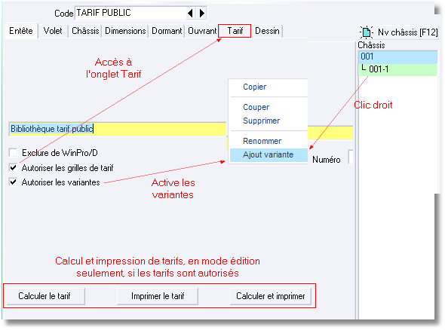
Header tab from library
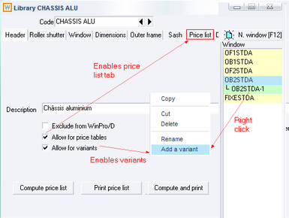

Price list tab
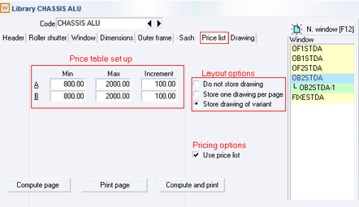

Printing
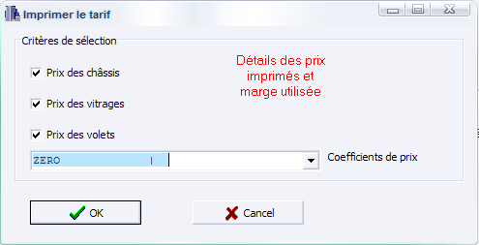
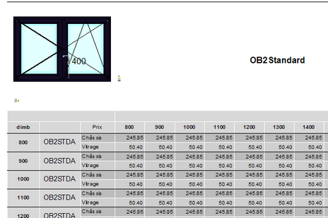
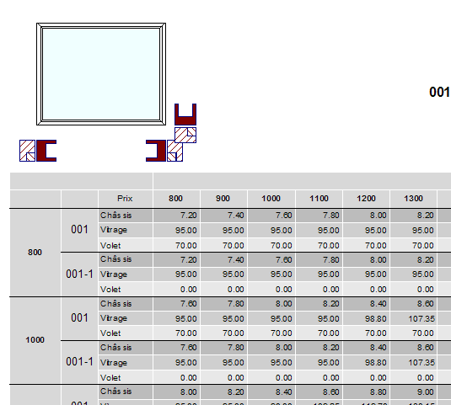
For WPR/WPR+ users, the reports used for the printings are available as models into the reporting program, you may then create copies of those in order to define your own layout, using menu Report | Creation to run WPR then using the button Copy standard report to create of a copy of the originals, from models « Entire price list » or « Siple price list».

New variable FalseArchCateg and an associated numeric field « Category » into false arches set up, from menu Technic | Window | False arches. This variable may be tested at outer frame and sash frame levels.

Modified tables (MySQL & Foxpro) | Created tables
Vitrage  Panneau  PannDeco  PannFabr | FillCateg

Filling selection filter feature: A new functionality is available at filling selection level during order input, which allows the user to filter the list of possible fillings by user defined categories, using a new combo button located on the right of the filling code selection in an order. This feature is available at any input level where WinPro offer this dialog (Design tab, Sash tab, Change glazing context menu...).
View of the Design tab of an order or quotation, pre-selection of a filling filter
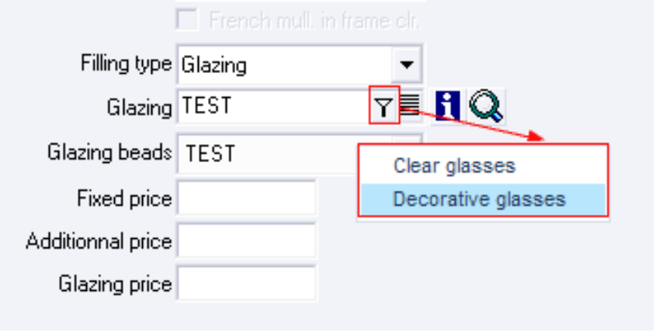
To enable the feature, a new filling categories menu is available through Data | Miscellaneous | Filling category. This file contains the 3 following fields:

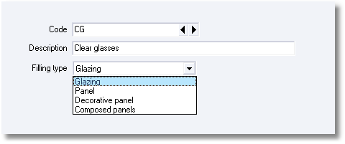

- Code : code of the category
- Description : description de la category
- Filling type: defines the type of the concerned filling, between glazing, standard panel, decorative panel and composed panel

Once the table is set up, a new combo is to be assigned by user for every concerned filling (glazing, standard panel, decorative panel, composed panel), the Selection filter field within Description tab of fillings.

Sample of glazing record, selection filter for this glass unit code:
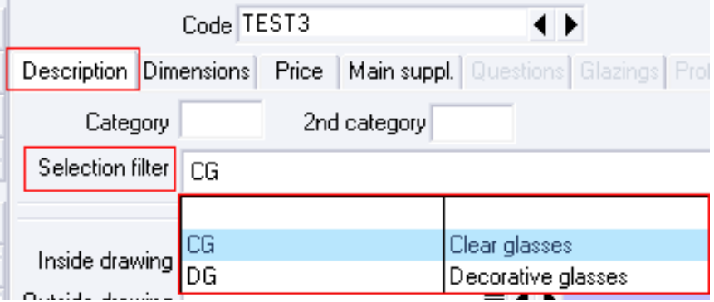

WinPro/D Internet mySQL: A new version of WinPro/D has been built, supporting mySQL database format. Along with the network performances that mySQL is famous for, this particular build will allow to centralize the WinPro/D databases into the same mySQL, which will make easier the management and deployment of the reseller versions. Refer to the specific release note of this product for more details.

Version 8.01
Compatibility 7.2 | Yes

Version 8.01.073 | 27/06/2010

User rights concerning customers: In the interface of the Customer record, the button allowing to toggle a customer as prspect is now disabled for users without the access right for « Customer ».

Version 8.01.xxx

Supplier order for roller shutter: A new combo into Roller shutter box file allows setting a supplier code for the whole roller shutter. This enables a new checkbox into the Actions tab, the Order supplier roller shutter form. This supplier document will sum up the main information of the design along with its drawing, questions and accessories articles, without valuing.
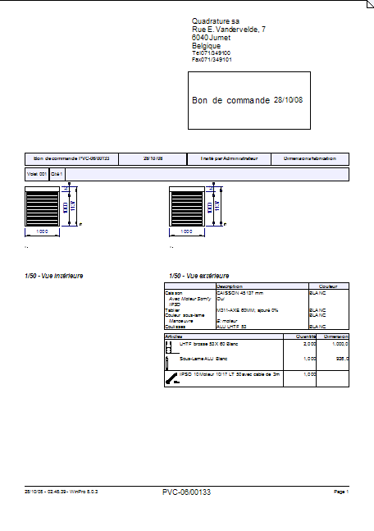

Compatibility 7.2 | No

Optimization : In order to grant a correct management of wastes storage, WinPro must be sure that a single optimization operation is processed at once. To master this conflict, WinPro create and lock a file called « lock.dbf » before running the optimization process. This also grants the release of this lock by the operating system in case of connexion lost between WinPro and the network, for instance.
The same mechanism is kept as is into version 8. Under a MySQL database, this involves a constraint with WinPro’s deployment. Indeed, users of WinPro MySQL version do not need anymore an access to a common shared directory; it will even be the case when connection to the database is done through the internet. At the opposite, users with rights granting access to the optimization process should, them, have such a common program directory. The lock file mentioned will therefore be created into such a directory.
Anyway, if the transaction system related to InnoDB format is used, this system will grant by itself the uniqueness of optimization occurrences, which will then raise the constraint of a common directory down.

Wood systems: In order to clarify the wood system set up, we have modified the layout of header pages of set up dialog for outer frames, sashes, transoms and peripheral profiles.
A new value is now available into table Settings, allowing to set the appearance of the profile section displayed within those header tabs.
To set this value, you must add a record into Settings table, System section (format integer I), as follow:

[System]
Wood = 0 Display of a PVC profile type by default when required, default value
= 1 Display of a wood profile type by default when required
= 2 Display of a wood profile type systematically

Zero is default value, and is set for a profile layout as a PVC type profile into the header tab. In case of a system with box “Wood system” checked, the layout for a component such as outer frame, sah, transom or peripheral profile will be a wood type layout..
If value is 1 (one), default layout is a wood type profile, and the layout will vary as for value zero when Wood system” box is checked or not.
If value is 2, the layout will always be a wood type profile, whatever the system type is.

Multiple InfoCli sets generation for WinPro/D (INF module): The creation of reseller databases of WinPro may appear slow and fastidious in case there are several databases to process at the same time. In order to make it easier, a new menu has been added Utilities | Generate multiple InfoCli sets to help the user with this task, but also for update processes of multiple resellers at the same time:
- Generate InfoCli files with the same options as previously through menu Utilities | Customer information for WinPro/D (same access code, base price coefficient, current price or list price computation, price grids rounding, discount by window, validity date), using button create, but with ability to select multiple reseller into the dialog
- Filter the reseller list regarding validity dates of their versions
- Set a validity date individually by reseller
- Show and modify the price coefficient of each reseller individually
- Customize target directories for generated files by reseller
- Update those same settings for multiple reseller at the same time

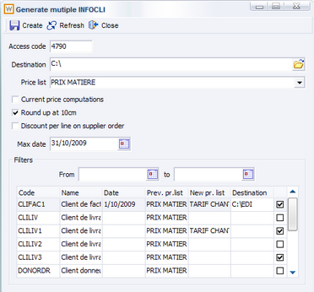

In order to help you with naming of the destination directories for the multiple files to generate, the module offers a list of keyword that may be used into the destination path.
For instance: when you define such a path « c:\infocli\#CODE# », Infocli will replace this path with « c:\infocli\ » followed by the reseller code. Here is the list of keywords proposed.

List of keywords
#coderep# | Code of the representative
#namerep# | Name of the representative
#code# | Code of the reseller
#name# | Name of the reseller
#zip# | Postal code for the reseller
#city# | Locality of the reseller
#country# | Country of the reseller
#date# | Validity date. This date is calculated with format: Year_Month_Day

Full bar optimization: Previously, WinPro didn’t list full bar length cut for an optimization onto the optimization documents and labels. A new option now allow a profile to be listed in case the cut length is equal to the bar length, using the appropriate checkbox into the optimization tab of the profile set up.

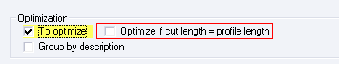

Archiving features for orders and quotations: 5 archiving methods are accessible into WinPro through menus from Orders | Delivery handling

Archive :

This method only applies to customer orders already invoiced or closed, when GP module (production management) is enabled into your licence file. Otherwise, any order or quote is concerned.
You may select manually the list of orders into the dialog, or use available filters for input date, range of delivery date, encoder code or customer code.

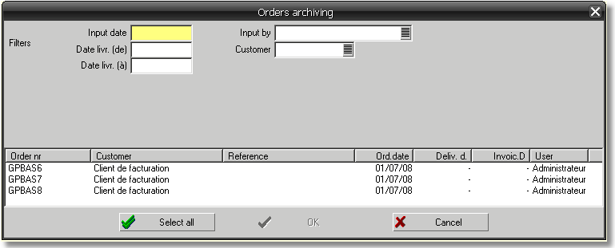

Orders are exported into a target directory specified by [LastPath] section, Archive key into settings table, under filename « Order_Or_Quote_Number.WPA ».
Concerned tables are COMMANDE, COMMANDE2, DETAIL, DETAIL2, ARTCDE, TRAVDORM, TRAVOUVR, REHDORM and ACCOUVR.
Exported orders will then be deleted from the database.
This method requires the user right for “Accounting”.

Archive to WinPro archive :

This method only applies to customer orders already invoiced or closed, when GP module (production management) is enabled into your licence file. Otherwise, any order or quote is concerned.
Those orders or quotations must be set with an invoice date equal or lower than the date specified into the dialog.
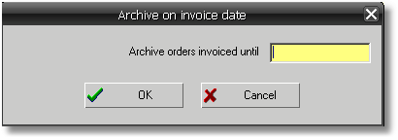

Using FoxPro database format, orders are exported into a target directory specified by [LastPath] section, Archive2 key into settings table, under filename « Order_Or_Quote_Number.WPA ».
Using mySQL database format, orders are moved from the current tables toward the target database, as specified by section [Archive DB], keys User, DB, Host, Port of settings table (refer to release note 8.03).
Concerned tables are COMMANDE, COMMANDE2, DETAIL, DETAIL2, ARTCDE, TRAVDORM, TRAVOUVR, REHDORM, ACCOUVR, CDELOG, CDE, DET, FEN, LIN, ART, VAR, VITREHDR, VITRECDE, VITRECRX et CHECKINGDATES.
Exported orders will then be deleted from the source database.
This method requires the user right for “Accounting”.

Archivage by date :

This method is only relevant for customer orders already invoiced or closed, with an invoice date lower or equal to the date specified into the dialog.

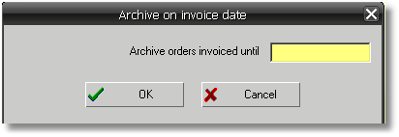

Orders are exported into a target directory specified by [LastPath] section, Archive key into settings table, under filename « Order_Or_Quote_Number.WPA ».
Concerned tables are COMMANDE, COMMANDE2, DETAIL, DETAIL2, ARTCDE, TRAVDORM, TRAVOUVR, REHDORM et ACCOUVR.
Exported orders will then be deleted from the database.
This method requires the user right for “Accounting”.

Archive orders and quotations :

This method applies to any order or quote when the user is not limited by the user right “Commercial user”, otherwise, any order or quote is concerned.
Orders and/or quotations must be set with a creation date between both limit dates set into the on screen dialog. A filter by type, order or quote, may also be used, as well as it is possible to manually select the required codes without filtering.

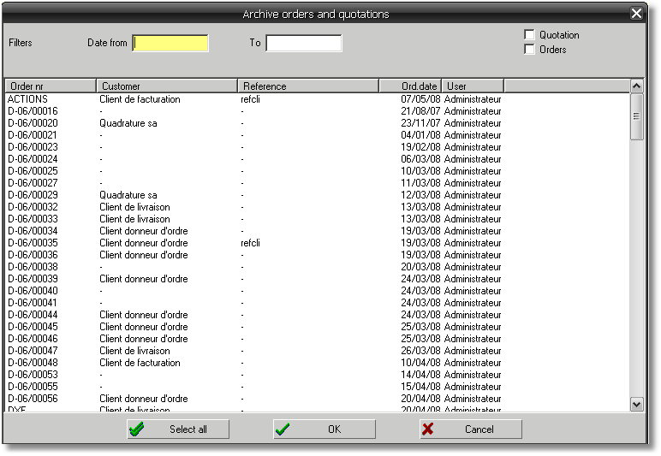

Orders or quotes are exported into a target directory specified by [LastPath] section, Archive key into settings table, under filename « Order_Or_Quote_Number.WPA ».
Concerned tables are COMMANDE, COMMANDE2, DETAIL, DETAIL2, ARTCDE, TRAVDORM, TRAVOUVR, REHDORM et ACCOUVR.
Exported orders or quotes will then be deleted from the database
This method requires module GP Production Management.

Delete orders and quotations :

This method applies to any order or quote when the user is not limited by the user right “Commercial user”, otherwise, any order or quote is concerned.
Orders and/or quotations may be filtered by a date creation range, or by type order or quote, or else selected manually into the displayed list

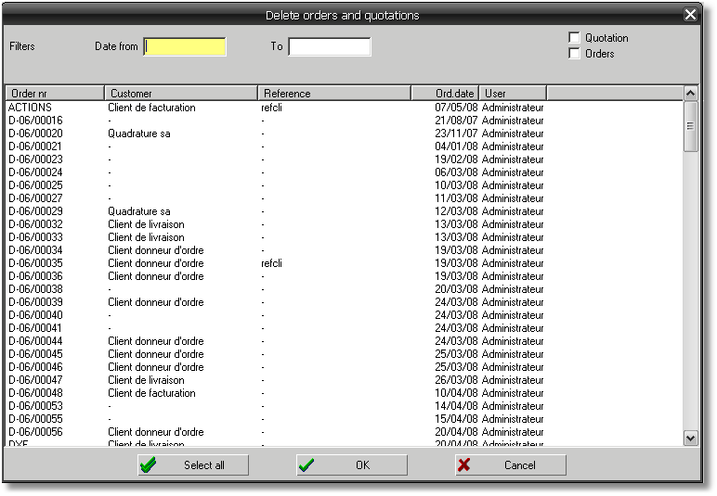

Concerned tables are COMMANDE, COMMANDE2, DETAIL, DETAIL2, ARTCDE, TRAVDORM, TRAVOUVR, REHDORM and ACCOUVR.
Orders or quotation will then be deleted from the database.
This method requires module GP Production Management.

Attention, no archive or backup file is generated using this menu, deleted orders and quotations are lost definitively when deleted with this feature !

Version 8.00
Compatibility 7.2 | No

WPR+ module: This module allows to create your own tables, to modify their structure or data content, using SQL queries (Insert, Update, Create, …).
Moreover, the query manager interface has been enhanced with the addition of new useful features, as the integration of native data connectors which avoid creating an ODBC data link onto the whole WinPro's workstation in a company.
A new version of the designer has also been developed, offering the following list of powerful features:

- integrated debugger.
- translation of the interface into multiple languages.
- selection of the development language to be interpreted (Delphi, C++, Java, ...).
- enhanced ergonomy.

Script language for mySQL versions: If you use WinPro with a mySQL database format, you may create and maintain your own tables thanks to user defined scripts.
For the program to handle such scripts, you just need to create a directory labelled « mySQL » into the base directory of WinPro, and paste here your scripts text format file with named « script_name.sql ». File names and internal syntax to use obey the following rules:

File naming :

Files « updatexxxx.sql » are used to create standard Winpro tables.
Files « update1xxxx.sql » are used for customer specific updates, as defined by Quadrature.
Files « update2xxxx.sql » to « update9xxxx.sql » are reserved for standard updates, as defined by Quadrature.
Files updateAxxxx.sql may be used by customers to create their own fields and tables.

The first file must be named updateA0000.sql; following files must be named by strictly incrementing by 1 the number part of the name, in hexadecimal notation. Any break in the numbering sequence will prevent the execution of scripts after the break.

Header :

# ; starts a comment line
NIL ; aborts processing of this script
winpro=1 ; this script applies to the main version of WinPro
winprod=1 ; this script applies to the dealer version of WinPro
create=1 ; if the table needs to be created
update=1 ; if the table needs to be altered
dict=1 ; alter the contents of the dict table
table=xxx ; name of the table to be altered or created

pierret=1 ; if update applies only to Pierret
fima=1 ; if update applies only to Fima
profel=1 ; if update applies only to Profel
hemmar=1 ; if update applies only to Hemmar
tivolux=1 ; if update applies only to Tivolux

One and only one of the 'create=1', 'update=1' and 'dict=1' instructions MUST be defined into a single script.
‘NIL’ instruction, if encountered at the start of a line, aborts the current script (next script is handled by WinPro)

Body for scripts 'create' and 'update' :

field=nnn;ttt[;ddd[;xxx]] ; to add or alter a field.
; nnn is the field name (in lower case; will be forced anyway).
; ttt is the field type and length. Do NOT insert any space! Example: varchar(16).
; ddd is the default value; leave one space if no default is to be defined but you need the extra information xxx.
; xxx is some extra information, such as 'not null', 'primary key', etc... (optional).
-field=xxx ; to drop a field - available only in 'update' mode.
index=xxx ; to add an index.
-index=xxx ; to drop an index. Available only in 'update' mode.
primary key=xxx[;yyy[;…]] ; to define a primary key.
&recno ; defines an auto-incremented field named 'recno'. Creates the necessary index.

Body for 'dict' scripts:

add=nnn;ttt[;ccc] ; to add or alter a record into dict table.
; nnn is the WinPro name.
; ttt is the table name.
; ccc is the import key (optional).
sub=nnn ; to drop a record into dict table.
; nnn is the WinPro name.

Sample of ‘dict’ script labelled « updateA0000.sql » :

# -------------- Header ---------------------
winpro=1
winprod=1
dict=1
# -------------- Records --------------------
# -------------- Table Actions --------------------
add=xmasteractionsart;masterartactions

Sample of ‘create’ script labelled « updateA0001.sql » :

# -------------- Header ---------------------
winpro=1
winprod=1
create=1
table=masterartactions
# ---------------- fields -------------------
field=typedoc;char(1); ;not null
field=commande;varchar(16); ;not null
field=type;tinyint;0
field=descriptio;text
field=quantite;double;0.0
field=dessin;varchar(255);''

Those scripts, when copied into a mySQL directory of the base folder, will add a line into dict table from WinPro (1st script), and will create a table named masterartactions (2nd script) containing fields TYPEDOC, COMMANDE, TYPE, …

It is strongly recommended to read the full document before processing any WinPro 8 deployment, if an old version is currently in use. Red points outlined must be read carefully

mySQL version 5
!!! Important note !!!
If you are using mySQL version 5.02 or higher, it is necessary to modify start up settings. To do this, locate the file my.ini, and find the following line into the file:
sql-mode="STRICT_TRANS_TABLES,NO_AUTO_CREATE_USER,NO_ENGINE_SUBSTITUTION"
replace with the following line:
sql-mode="NO_AUTO_CREATE_USER,NO_ENGINE_SUBSTITUTION"
Without this change, mySQL won't accept to record date field sent by WinPro if those ones are empty strings (mySQL 4.1 accepted to record the associated default value for the date field).
Moreover an important operation is to be processed on the server in order to allow WinPro to create users from workstation.
Onto the mySQL server, from mySQL Query Browser program or straight within a console command line of mySQL server, enter the following instruction :
GRANT ALL on `xxx`.* TO ‘uuu’ IDENTIFIED BY ‘ppp’ WITH GRANT OPTION
xxx is replaced with the WinPro database name (alternatively, ‘xxx`.* can be replaced with *.*, which will affect any database already existing or to be created), uuu is replaced with the user code ‘root’, ppp is replaced with associated password for the ‘root’ user.
Attention, we insist on the fact that this instruction must be set onto the server itself, and not from a workstation !!! Indeed mySQL defaultly grants the right for user creation only for the administrator working straight on the stand alone server, exluding any existing workstation.
As a last note, this instruction must be set just after the database creation by WinPro (or manually using the database manager), but before importing the data set within created database.

WPReport
WPReport module has deeply evolved with version 8 (see below). Unfortunately this upgrade will leave old version 7 reports incompatible with version 8 (even though the conversion process from version 7 to version 8 will automatically be done for the reports when upgrading for version 8). Therefore if you use version 8 for testing purposes, and you are still using version 7 for production, it is strongly recommended to work on a copy of the version 7 production database.

New licence format
Version 8 introduces a new format for the licence file. Please be sure this new format licence has been supplied by Quadrature. This file must be copied into the WinPro base directory, nothing else has to be done for the new licence to work.

If mySQL version 8 is installed before 1st of january 2007
WinPro modifies the name of WinPro tables under mySQL, to enable the compatibility with the FoxPro version, especially for WPReport. The modification consists in renaming the table names in order to correspond to the exact FoxPro table names.
Procedure to follow for installation of latest version 8 from a version 8 older than before 1/1/2007 :
- Export the full current database into a given directory
- Delete from current installation the mySQL directory located into the base directory of WinPro.
  - Alternatively, you may create a new WinPro directory to keep the old version as is.
- Install the new WinPro files.
- The you may choose between 2 different methods
  - You may create a new database, with a new name (recommended)
  - You may delete the old database and reinstall the new version under the same name (not recommended)
- Finally, import the database into the selected mySQL database

Introduction
WinPro version 8 introduces a major evolution into its database: you can now switch between a database into FoxPro or mySQL format.
Consequently, all WinPro’s database access functions have been programmed into two DLLs, one for FoxPro format database access and one for the mySQL format. Those DLLs names are respectively FoxProData.dll and mySQLData.dll. You may choose between both formats simply by adding a section into winpro.ini file (see below ‘Installation’).
At the user point of view, the usual features and behaviours of WinPro are quite identical whatever the database format is. But the changes will quickly appear when experiencing enhanced performances, secured accesses and internet connexion capabilities that offers the program.
Indeed, WinPro using mySQL enables for the users a complete and total access to the database through Internet, allowing performances reaching those observed using a version 7.0 of WinPro through a LAN (this is obviously depending on the Internet connexion effective bandwidth).
Moreover, still using mySQL version, it will be possible to have a safer access to the data by strictly restricting direct access to the database, this just with using a single TCP/IP connexion even through a LAN. The database is then secured from any disallowed access.

mySQL
This version is tested under mySQL 5.0 Enterprise. Future mySQL versions will of course be validated along with their availabilities.
WinPro cannot work with mySQL versions older than mySQL 5.0.

WinPro.ini
After WinPro upgrade process, this file will only define which database will be accessed. All others previously contained settings are stored into the database itself, respectively into a table named ‘Settings’ using mySQL, and ‘data\settings.dbf’ using FoxPro format. Unneeded information other than the [Database] section can then be deleted (be sure to do this only after WinPro’s upgrade process !!!). Anyway, this is not a needed step.

Installation
Several basic steps for the set up:
- Make a backup of the existing installation!!!
- Upgrade your version 7 toward the latest version 7 available onto our ftp server. Fully reindex your version 7 database as a precaution.
- Install WinPro 8 version including the following files:
  - Winpro.exe
  - WinPro.lic or WinPro.lc2 (according version 8 in use)
  - Mysqldata.dll
  - Libmysql.dll
  - Foxprodata.dll
  - WpReport.dll
  - Modules.dll
  - StdReports.dll
  - XStrings.exe
  - A mySQL directory (for version < 8.1)
  - A FoxPro directory (for version < 8.1)
  - Strings.(*) files
  - A specific.dll file, in particular cases
  - The Report subdirectory of version 7 also needs to be copied into the version 8 installation directory, in case you want to convert your version 7 existing WPR reports into version 8 (see point below)
If you which to keep WinPro using FoxPro format database, the installation ended here ! For the mySQL version set up steps, see point 8.
- For WpReport module users under version 7, if you want to upgrade and use your existing reports with version 8, don’t forget to copy the Report directory from version 7 into the version 8 installation directory ! Otherwise, WPR existing reports would be incorrectly updated and would be unusable with version 8 ! Please note that once correctly converted, reports are usable with version 8, but only using the old designer mode from WPR ! Reports created with version 7 are indeed not compatible with the new designer feature from WPR within version 8 ! Moreover, some of the queries used into the version 7 report might have to be adapted for version 8 when the reports are managing a mySQL database rather than a FoxPro database, the SQL FOR FoxPro syntax varying compared to SQL syntax for mySQL.
- Be sure that the mySQL database is correctly installed, and that you have a full user access right account enable for the database. To obtain the last mySQL version, refer to mySQL AB web site, www.mysql.com. Contact our services for any help about mySQL installation.
- Run the new version of WinPro. The program starts with a default FoxPro format mode.
- Go to Utility menu, and ‘Export database’. Warning !!! Never select ‘Import database’ menu at this step, this would totally delete your FoxPro format database !!! Be sure to apply processes required at step 1, don’t forget to backup the database !!! This will extract all the FoxPro format database records into text files that will be stored into a sub-directory in the WinPro base directory. This process may last depending on the size of the database and the bandwidth of the network.
- Quit WinPro.
- Add the following section into WinPro.ini file :
[Database]
DLL=mysqldata.dll
Host=xxx
Name=yyy
Engine=zzz
Transactions=bbb
Character set=ccc
xxx is replaced with the hostname or IP address of the server (e.g. 192.168.1.1, www.Company_name.com, etc…)
yyy is replaced with the database label you want to assign to the database (WinPro will create it automatically). Examples : winpro, production, …
zzz is replaced with the type of database engine you wish to use. For a basic installation, you can choose between ‘InnoDB’ and ‘myISAM’. We suggest to use the InnoDb format for LAN or internet access. This engine supports transactions which appear to be safer. For a stand alone installation, the myISAM engine is enough as it is much more compact and lightly quicker.
bbb is to be replaced with 1 (default), or with 0. In case of value 1, WinPro will process a given number of processes (e.g. optimization) within a single transaction. Nevertheless, this may result in certain cases in slowing the overall system. This value may then be replaced with 0, but be aware that this option may cause operations to be a bit less safe. Note that in any cases, tables of myIsam format do not support such transactions, this option will then have no effect onto those tables.
ccc contains the character set to use; the default value is latin1, suitable for languages from occidental Europe area (french, english, spanish, italian, german, etc...). This line is optional.
- Start WinPro. A new access control dialog appears:
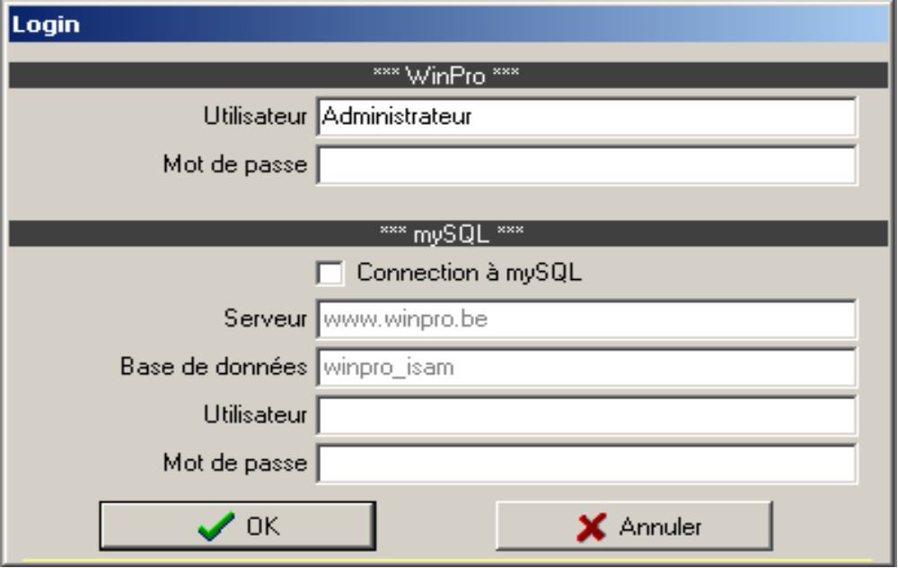The section *** WinPro *** correspond to the usual WinPro login.
For a first connexion, you must indicate to the system an access code to mySQL. To do this click on ‘Connection to mySQL’, and input your username and password, then validate. If your mySQL access is valid, WinPro will then create the database. This will take about some 10 seconds.
At this step the mySQL database is created, but is empty
- Without leaving the software, go to the Utility menu, ans select ‘Import database’. Be careful with this !!! Do not mistake here too as it may be less serious than at step 5 but you will have to revert to the FoxPro format to regenerate the export files of the database !!! WinPro will then access and read the database previously exported into text files. Once again this may last minutes depending on the volume of the database and the bandwidth of the network used.
- Quit WinPro. This must be done for the program to work properly !
- Restart WinPro. This time only the *** WinPro *** is needed. However this section may be used again to create or access to another database or for any reason.
Note : Import/export functionalities are bidirectional. It is then possible to export a database from mySQL toward FoxPro, and vice versa, as often as necessary.

Access control
Under FoxPro format, no changes: username and password are still needed to use WinPro, but a direct access to the database is not restricted.
With mySQL , a second level of access control is necessary. Besides WinPro access, you will have to input a username and password allowed by mySQL.
During installation this must be done explicitly.
However for future accesses, at the user point of view, only WinPro username and password will be required.
This is because when a database is imported into mySQL, or when a new user account is created, WinPro will create a user code and password (calculated) for mySQL. Those codes will be stored straight into the database, with transparency for the user. As those codes are calculated, the maximum length allowed for a code has been exploited fully, which make the code become very hard to discover.
Example of user code automatically generated:
User : 5D42100819143E1A (16 characters)
Password : F61295A889010AE0C2DBF7DC094F6C530B28DE0E (40 characters)

Other new features
We started implementing into WinPro software loads of new design shapes to be available in coming months. This leads us to modify the interface for the design shape selection.

Current development status
The current version includes all WinPro 7 features. Nevertheless, every specific development haven't been fully tested yet. If you use such specific features, please contact us before any installation, in order to define together a planning and a procedure for testing.

Future developments
The version of WinPro using mySQL allows foreseeing new modes of WinPro use:
- WinPro/D Internet : this should work as a standard WinPro/D program, but will allow to work on a single fabricator based database, authorizing the complete control to the database access. This program would be provided for free or at a very low price, but with a recorded quotation line payment method.
- Customer consultation: it is now possible to imagine a real time on line order status referring functionality for the customer.

Main differences with version 7
Translations for the database records are now stored within the database itself, into the Traductions table. This file contains 2 fields: a Langue field, setting the language code, and a Texte field, containing the whole translations input for the concerned language.
In order to keep a compatibility with the external applications using the old translation files (tra.* files), two new menu entries have been added allowing you to export the translations toward a given directory, and to import one or several translation files. Both menu entry points are located below the Translation sub menu of the Miscellaneous main menu entry.
This concerns only the translations of the database record (old files tra.*); translations for the interface and generic terms of documents are not concerned (strings.* files).
Customizable directory for export/import process of the whole database.
Enhanced interface for design shape selection.
WPReport has been deeply embedded. Among new features:
Access to any SQL instructions, including updates instructions.
Interactive construction of SQL commands into graphic mode.
New layout engine (the old engine is hold to allow compatibility of the reports with the new version).

Modification of data transfers toward WinPro/D
In order to be able to export data from mySQL as from FoxPro database, the transfer processes has been embedded.
Using WinPro, the transfer steps are the same. Anyway, the produced files are different: in the InfoCli procedure, files societe.dbf and societe.fpt are deleted (information contained into those files are now stored into the file licence.ini) ; into the technical data creation process, the program create now a single export file (data.pak), located into the Devis directory of WinPro base directory.
Using WinPro/D, the InfoCli procedure is kept (except that societe.* files are no more expected, but the new version of file licence.ini). Nevertheless, a new procedure called, ‘Import fabricator data’, into the ‘Utility’ menu, will be in charge of importing the technical database supplied by the fabricator (now contained into the file data.pak). This procedure allows to locate this file before importing. This procedure must be applied for any update of the technical dataset, and also after any version upgrade of file winprod.exe.

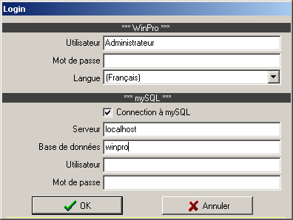
Users creation (mySQL)
In order to safely create new WinPro users, you must absolutely connect, during WinPro login, using a user code and a password granting sufficient access to the mySQL database.
Otherwise, the WinPro user will be created, but will not have access to mySQL database, and will then have no access to WinPro.
Alternatively, you can create WinPro user first with having sufficient mySQL access rights, then a granted user can connect using a correct mySQL access account, and will be able to record again each created users (display the user, then F3-F5 keys sequences).

Scripts management (mySQL)
Structural changes onto the database are automatically managed by WinPro, using script files located into the mySQL sub-directory.
The content of such scripts is reserved, and must not be changed by the user, as any changes done will be lost when WinPro will be updated.
Nevertheless, we anticipate to leave the user manage with his own script files, e.g. for adding new fields or even new specific tables. To allow this, a list of script numbers has been reserved for the user to implement his own scripts. Refer to the explanation file ‘syntaxe-xx.txt’, located into the mySQL sub-directory of WinPro, among usual scripts.

Views management (mySQL) (for advanced users only !)
It may be useful, for many reasons, to access VIEWs of tables instead of straight accessing tables. It may allow for instance to share a same table between several distinct databases.
Nevertheless, the management method for views within mySQL involves that if any field is added or removed from the original table, the change done onto the table structure will not be applied to the VIEWs created from concerned.
In order to bypass this limitation, a new table has been added to the database, named ‘views’. Each time WinPro will update a structure table, it will check into the ‘views’ table whether one or more records are concerned by the structure changes. If this is the case, it will extract from those records a SQL query and apply it.
The content of the ‘views’ table is then maintained by the user. The 'views' table contains 3 fields :
Table_name : name of the WinPro table that should launch a process when structure is modified.
Sql_stmt : A SQL statement to execute when the structure of table mentioned into the Table_name field is modified.
- Ordre : the sequence used to run the statements, when several statements are to be launched for a same modified table. Values into this field don't need to be consecutive, the field is used only to sort records in order to process them with a correct sequence. In case of 3 statements to run for a same table, you may number the statements as 1,2,3, or else 10,200,3000, or even 17, 43, 79, as an example. If a statement sequence is unnecessary, you may leave this field blank.
For VIEWs management, it is recommended to use the syntax ‘CREATE OR REPLACE VIEW’ instead of a single ‘CREATE VIEW’ statement. The statement will then be applied, whenever database exists or not, which is safer. As a view does not contain any data, the systematic replacement is always safe.
Please note that in case of error on running a statement stored into the ‘views’ table, an error message is displayed, and WinPro's running will be aborted.
Please note also that the use of this feature is largely overriding the VIEWs management feature: it is in fact a feature allowing the execution of one or many SQL statements after the modification of a structure table, like a trigger would be enabled after an ALTER TABLE statement. Any SQL statements with no returned values may be used here: e.g. INSERT, DELETE, ALTER TABLE, CREATE TABLE, …
Please finally note that this procedure only concerns modifications of table structures done by WinPro. Those changes won't be applicable for modifications done manually by the user into the database.

